# Earth Tides

Contents

Earth Tides 1

1. Introduction 1

1.1 Solid tides 1

1.2 Gotic2 2

2. "Earth tides" layer in GeoTaos_map 2

References 4

## 1. Introduction

GeoTaos_Map has a built in map layer named as "Earth tides" which provides utilities estimating deformation and stress caused by the tidal forces. Tidal response at any given point on the earth for any given time or period can be theoretically calculated. There are two build-in or plug-in calculators in GeoTaos::Earth tides. The 1st one is "Solid tides" which calculates solid tides at near surface region. The 2nd one is Gotic2 program which has several options for the calculation of solid tides and ocean loading. At a location close to any of the oceans, where ocean tides are important, the Gotic2 program should be used. It is also possible to include tidal loading to the calculation of △CFS for given faults.

## 地球潮汐分潮

地球潮汐中的日潮（全日潮）和半日潮是由月球和太阳引力作用引起的短周期潮汐现象，通过谐波分析可分解为多个分潮。以下是主要分潮及其特征：

### 一、日潮（全日潮）

周期约24小时，每日出现一次高潮和低潮，成因与月球或太阳的赤纬变化（纬度效应）有关。

主要分潮：

1. K₁（日潮-合成潮）

- 周期：23.93小时

- 成因：月球和太阳的共同作用，由月球轨道倾角和地球自转轴的倾斜共同调制。

- 特点：全日潮中最强分潮，赤纬越大（如春秋分），K₁潮越显著。

2. O₁（月日潮）

- 周期：25.82小时

- 成因：月球赤纬变化导致的全日潮分量，与月球的轨道倾角有关。

3. P₁（太阳日潮）

- 周期：24.07小时

- 成因：太阳赤纬变化引起的全日潮分量，与太阳直射点季节移动有关。

4. Q₁（椭圆修正全日潮）

- 周期：26.87小时

- 成因：月球轨道椭圆性对全日潮的修正效应。

### 二、半日潮

周期约12小时，每日出现两次高潮和低潮，成因与月球或太阳引力的对称性有关。

主要分潮：

1. M₂（主太阴半日潮）

- 周期：12.42小时

- 成因：月球引力的直接作用，是潮汐中能量最强的分潮，占主导地位。

2. S₂（主太阳半日潮）

- 周期：12.00小时

- 成因：太阳引力的直接作用，强度约为M₂的1/3，叠加形成大潮和小潮。

3. N₂（椭圆修正半日潮）

- 周期：12.66小时

- 成因：月球轨道椭圆性（近地点和远地点）对半日潮的周期性调制。

4. K₂（合成半日潮）

- 周期：11.97小时

- 成因：月球和太阳赤纬变化的共同作用，与K₁对应，但为半日周期。

5. L₂（次太阴半日潮）

- 周期：12.19小时

- 成因：月球轨道升交点进动对M₂的修正效应。

### 三、其他重要分潮

- 混合潮：如K₁和O₁的相互作用可能导致某些区域潮汐类型（全日潮、半日潮或混合潮）的变化。

- 浅水分潮（如M₄、MS₄）：由潮波在近岸浅水区非线性变形产生，周期更短（约6小时）。

### 四、实际影响

- 潮汐类型：

- 半日潮区（如中国东海）：M₂和S₂主导，每日两涨两落。

- 全日潮区（如南海北部）：K₁和O₁显著，每日一涨一落。

- 混合潮区（如太平洋中部）：半日潮和全日潮分量强度相近，潮高不规则。

- 天文大潮：当太阳（S₂）和月球（M₂）分潮相位叠加时，形成朔望大潮。

### 五、五长（半月-年周期）分潮：

1. Mm（月赤纬周期）：约27.55天

2. Mf（半月周期）：约13.66天

3. Ssa（太阳半年周期）：约182.62天

4. Sa（太阳年周期）：约365.26天

5. Msf（月-太阳合成周期）：约14.77天

### 1.1 Solid tides

"Solid tides" is a fast calculator of synthetic solid tides. The tidal corrections of surface displacements caused by lunar and solar gravitational attraction are calculated using the nominal second degree and the third degree love numbers and Shida numbers (h20 = 0.6078, l20 = 0.0847, h3 = 0.292, l3 = 0.015).

Strain tensor can be computed by:

$ε_{xx}=ε_{λλ}=\frac{1}{r*cos⁡(φ)}\frac{∂u_{λ}}{∂λ}-\frac{tan⁡(φ)}{r}u_{φ}+\frac{u_{r}}{r}$ (1)

$ε_{yy}=ε_{φφ}=\frac{1}{r}\frac{∂u_{φ}}{∂φ}+\frac{u_{r}}{R}$ (2)

${2ε}_{xy}={2ε}_{λφ}=\frac{1}{r*cos⁡(φ)}\frac{∂u_{λ}}{∂λ}+\frac{tan⁡(φ)}{r}u_{λ}+\frac{∂u_{λ}}{∂φ}$ (3)

where z (r, radial, upward), x(eastward), y(northward), λ, ϕ are longitude and latitude, respectively.

Near the earth's surface, where the boundary is stress-free, the vertical strain can be estimated by:

$$ε_{zz}=ε_{rr}=\frac{-λ}{λ+2μ}\left(ε_{xx}+ε_{yy}\right)$$

$=-\frac{1}{3}\left(ε_{xx}+ε_{yy}\right) (ν=0.25)$ (4)

From (4), the ratio of volumetric strain to area strain in the near surface region is about 2/3. Following approximation works quite well and thus can be used to estimate shear strain components on vertical planes from tilt.

$ε_{xz}≈-1.8T_{e}$ (5)

$ε_{yz}≈0.375T_{n}$ (5)

where Te (positive for upward-east) and Tn(positive for upward-north) are titles along north direction and east direction, respectively.

### 1.2 Gotic2

Gotic2 is a program developed by Matsumoto et al. for prediction theoretical solid tides and ocean loading effects [*Matsumoto et al.*, 2001; *Matsumoto et al.*, 2000].

## 2. "Earth tides" layer in GeoTaos_map

2.1 Time series of tidal deformation

|  |  |
| --- | --- |
|  | [1] Define longitude and latitude in degree.  [2] Give altitude in meter  [3] Time zone  [4] Time or start time of a period  [5] Days of the period and interval in minute  [6] Click [Run] to calculate the time series.  [7]-[9] Options for ocean load  [11] Click [Run] to calculate the time series using Gotic2. |
| [13] Number of grids in EW and NS directions  [14] Z range in meter  [15] Grid number in vertical direction  [16] Click [3D Mesh] to calculate tidal deformation at 3D Meshes. The results are stored in 3D mesh map and will be added to the "Base image" group.  [18] Selection for including tidal stress in dCFS calculation |
|  |

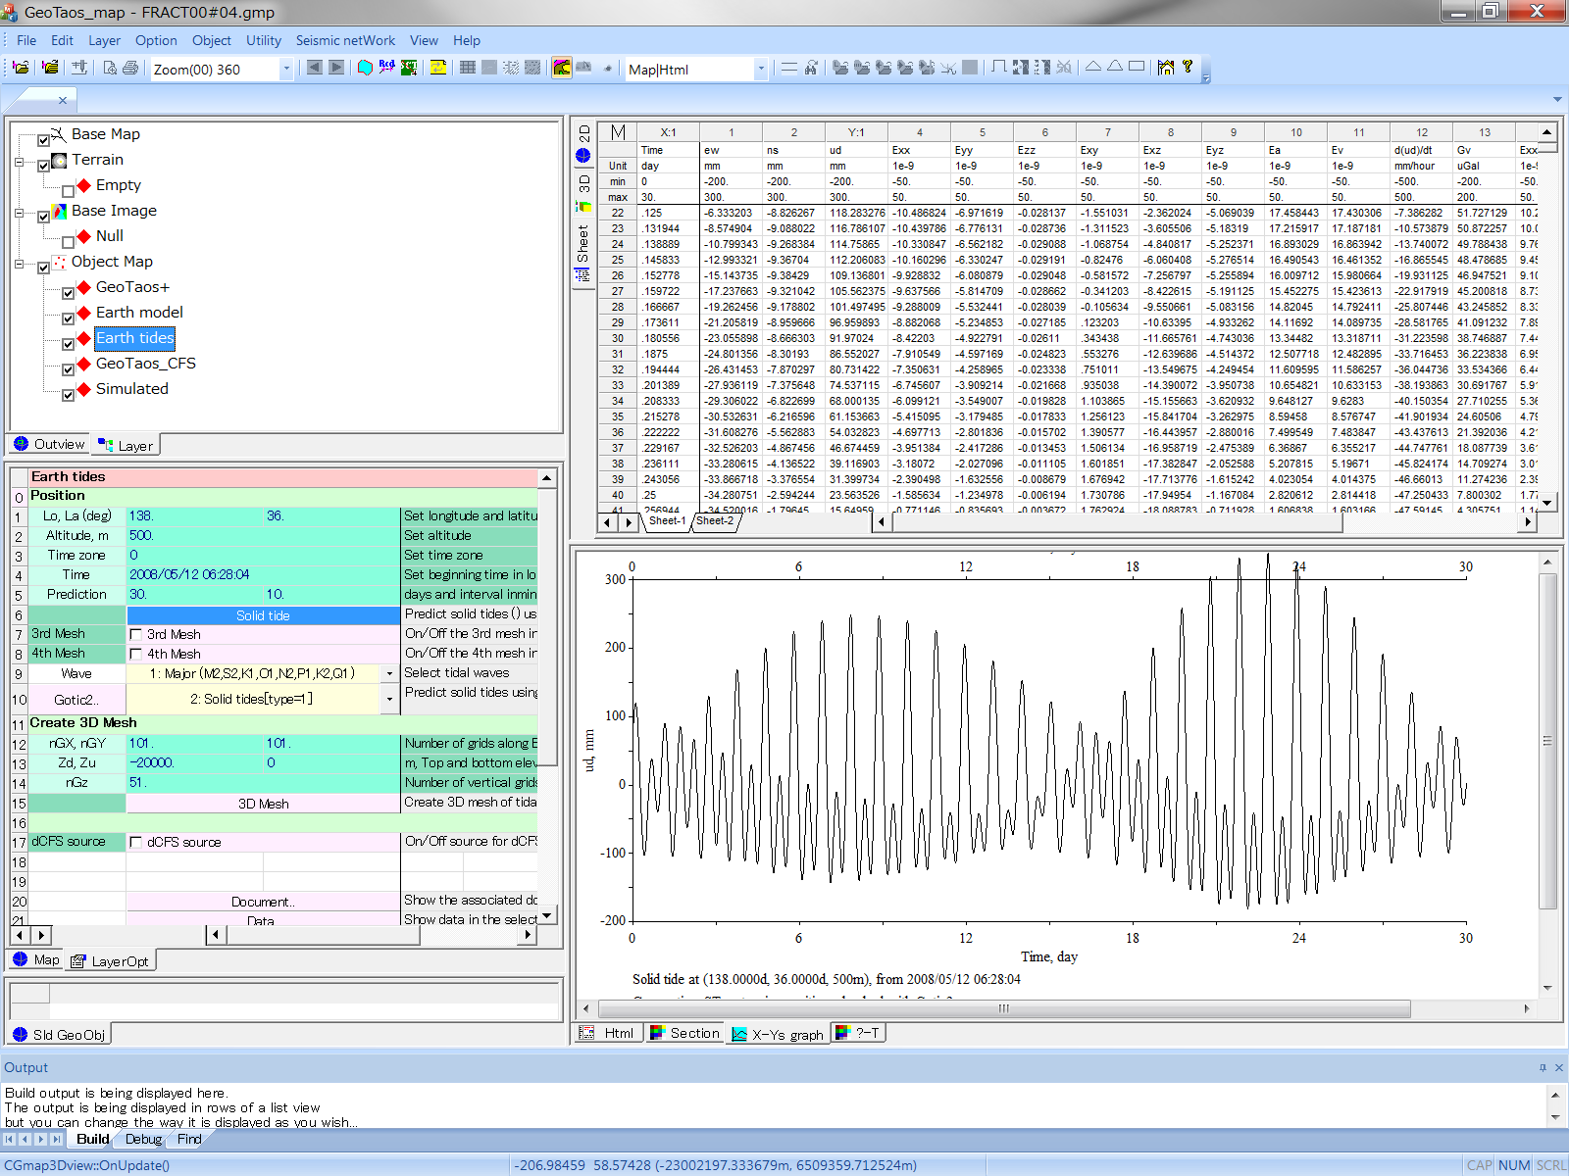

Tidal deformation calculated at a given position for a period

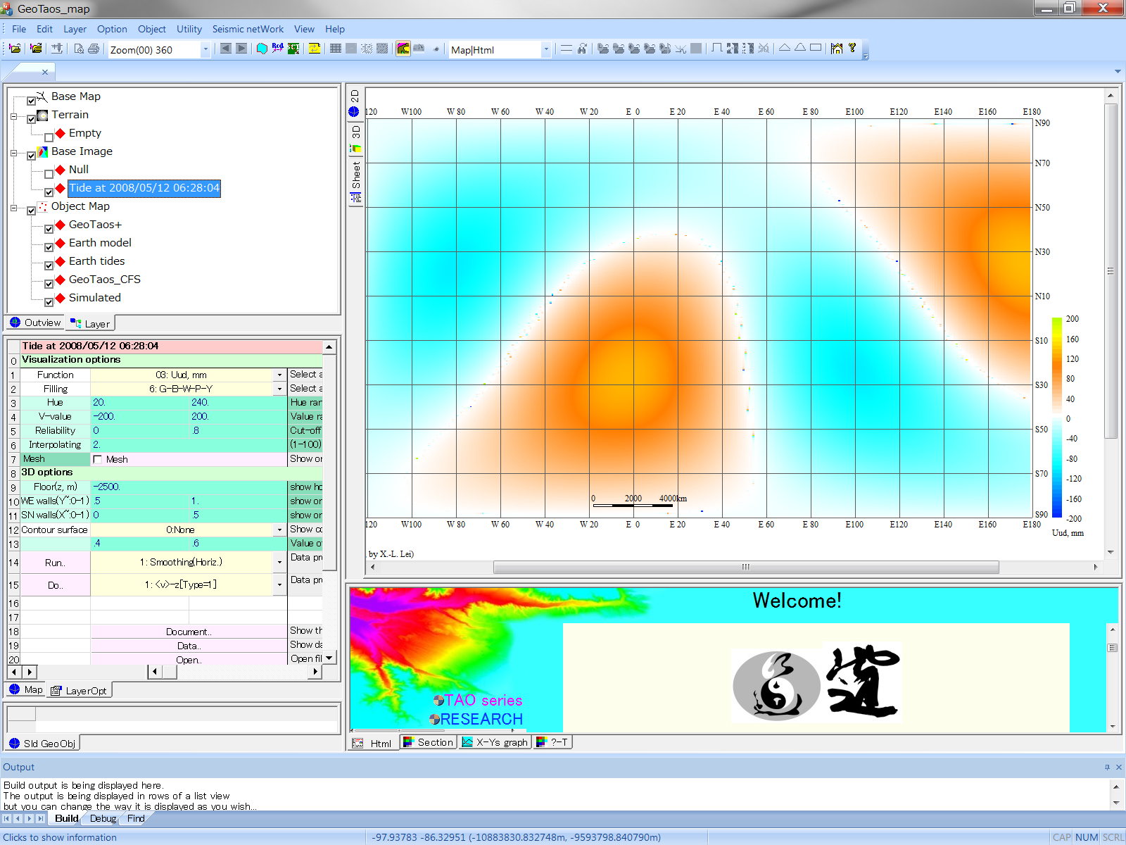

Tidal deformation calculated on 2D/3D meshes

## References

Matsumoto, K., T. Sato, T. Takanezawa, and M. Ooe (2001), GOTIC2: A Program for Computation of Oceanic Tidal Loading Effect, *測地学会誌*, *47*(1), 243-248.

Matsumoto, K., T. Takanezawa, and M. Ooe (2000), Ocean tide models developed by assimilating TOPEX/POSEIDON altimeter data into hydrodynamical model: a global model and a regional model around Japan, *Journal of Oceanography*, *56*(5), 567-581.